# **LAYING THE FOUNDATION FOR YOUR MARKETPLACE JOPURNEY**

## Choose Your Marketplace and Define Your Business Goals

The diagram below highlights the marketplace I have chosen and the visual description of business goals.

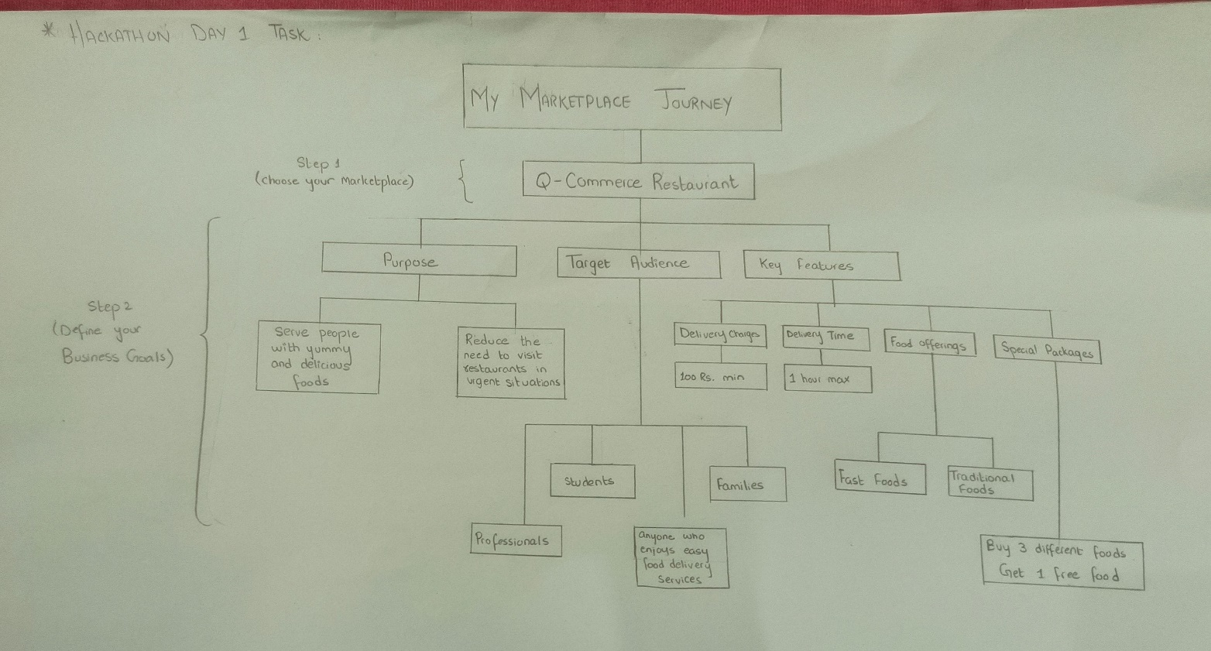

This diagram illustrates a marketplace journey for a Q-commerce restaurant, highlighting its purpose, target audience, and key features. The purpose of the restaurant is to serve people with yummy and delicious food while reducing the need to wait during urgent hunger situations. The target audience includes students, families, and professionals, particularly those requiring fast delivery and quick service. Key features of the restaurant include delivery options within 30-50 minutes, dine-in facilities, a wide variety of food offerings such as fast foods and traditional dishes, and special packages, such as “buy 3 different foods and get 1 free.” This approach emphasizes convenience, quality, and customer satisfaction.

## Create a Data Schema

The diagram below highlights the entities of my marketplace and their relationships. This diagram also illustrates fields for each entity.

